# Computer networks

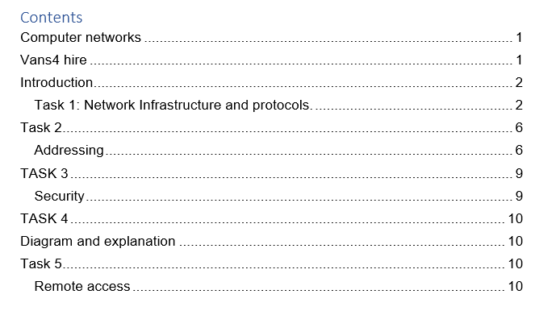

# Introduction

Vans4hire is a company which provides vehicles on a temporary basis to business and individuals. It has 2 head offices in Leads UK and is considered a small enterprise with 25 employees. The managing director is ready to expand and to response request from his business customers. I have been called in to help design the new network to improve performance and security. I should be helping them to create a network solution, providing Internet access for office staffs and network access between two head offices. I also need to provide them with VIOP telephony and a secure way to access flies from the head office. The hard ware they have is mostly old so they want me to replace hardware to match the modern system capable of providing performance, security and storage including backups.

## Task 1: Network Infrastructure and protocols.

a). We have to use both option for providing network as Ethernet is suitable in some scenario it may not be suitable in others. Due to Ethernet cable using cables, it tends to work slightly faster and is more secure and in other hand Wi-Fi can come to handy, as it provides the convenience of using it within range. Thus, the choice lies between speed and convenience. The head office has the Collection of 10baseT over Cat5 UTP.

|  |  |  |
| --- | --- | --- |
| CAT 5 | CAT 5 E | CAT 6 |
| Cat 5 cables were made to theoretical speed of 10mbs to 100mbps.  Particularly if it’s short. | Also known as Cat5e is the new versioning Cat5 cabling. In theory cat5e can support up to 1 gigabit of speed. | CAT6 is the improvement over cat5e.In theory it can support speeds up to 10 gigabits and work up to 250mhz |
| Solid CAT5 cables are mostly preferred for long distance transmissions | Cat5e also can also be used for Gigabit Ethernet and has less near-end crosstalk. | . Although it is comprised of four pieces of the twisted pair wire. Which allows the cables to be separated from each other and, which helps for an increased data transfer speed, but less crosstalk which double’s the bandwidth |
|  | The ‘e’ stands for enhanced. This cable has more the ability of the transmission of data with less interference than in CAT 5 | CAT6 is compatible with both CAT5 and CAT5e cabling. |

Chances are changing your cables isn't going to make much of a difference as cables don’t increase the net speed. But the way you send and receive data behavior determines the speed of the internet, in short, if you transfer lots of data over your network, upgrading your cables from old Cat5 might help, which is very affordable and best in its price range.

B).Hub, switch, a wireless access point and router are networking components. Differences between them are as mentioned below.

|  |  |  |  |
| --- | --- | --- | --- |
| Hub | Switch | Router | Wireless access point. |
| Hubs are generally used for connecting computers in a communication network with each other. | Switches and hubs function mostly same. Switches have the function of identifying the intended destination of the information they, so they only send information to the computers that it’s intended for. | Routers are intermediary devices which enables a computers and other network devices to communicate and pass information between two networks. | Access points are meant to provide wireless access of a wired Ethernet network. An access point plugged into a hub, switch, or wired router then sends out wireless signals |

|  |  |  |  |
| --- | --- | --- | --- |
| A hub has the capability of sending and receiving information but doesn’t have the capability of doing it at the same time. | Switches is capable of sending and receiving information at the same time, and faster than hubs. Recommended in places where u require to be passing information or data a lot | Routers have the capability to direct network traffic. It also has its own security system. | Provides range as you can be connected to it even when you’re not seated at the same position. |

Hub is in the data link layer as it transmits on the basis of mac address. Hub sends the packets to all connection not just the one with mac address.

Switches operate in the network layer as the multiport network bridge which uses hardware addresses to process and forward data at the data link layer.

Routers operate on the network layer where packets are sent to a specific next hop IP address, based on destination IP address.

Wireless access points are bridge they also operate on the data link layer as switches do.

C).The OSI model is the most popular universal language used in computer networking. It’s based on the concept of splitting the model up into seven abstract layers, each one stacked upon the last. Here are some of the layers and what they do

|  |  |  |  |  |  |  |
| --- | --- | --- | --- | --- | --- | --- |
| Physical layer | Data link layer | Network layer | Transport layer | Session layer | Presentation layer | Application layer |
| Transmits raw bit stream over physical medium. | Defines the format of which data is the network | Decides which physical path will the data take | Transmits data using transmission protocol(TCP) | Used mostly for opening and closing communication between two different devices. | This layer is responsible for repairing data so it can be used by the application layer | Layer that directly interacts with data from the user. |

d).A protocol is a set of rules which checks the communications between computers devices on a network. Here are some of the protocols and in which OSI layer they operate.

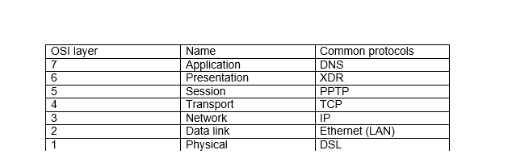

DNS:  Domain Name System – translates the network address like 192.168.2.1 into terms understood by user like www.google.com.

XDR: It stands as External data representation. It involves under the layer of 6th OSI Layer i.e. presentation layer.

PPTP: It stands as area point to area point tunneling .It is also used to synchronize clocks throughout the network.

TCP: It is originated in the initial network implementation to complement the IP. That’s why it’s also called TCP/IP

IP: It is a common protocol at network layer. Its routing function enables internetworking, and essentially helps to establish the internet.

Ethernet (LAN): The Ethernet is a local area network (LAN) set of protocols which serves the physical and data link layer. Ethernet uses CSMA/CD when transmitting packets.

DSL: It is a technology that uses high bandwidth lines to transfer data over telephone lines .It uses telephone singles to transfer digital data.

# Task 2

## Addressing

A).Network components need addressing to create communication between networks .Addressing is useful for uniquely identifying the host for the network .It uses IP address and mac address to find the host here are some difference between them.

|  |  |
| --- | --- |
| M.A.C address | IP address |
| Mac stands for media access control which has a unique number or a code to indicate separate devices on a network. It is assigned by the manufacturer. Essential to make local Ethernet function. | IP stands for internet protocol. It is the set of rules can control the internet activities. It helps to establish connection between networks and Through internet. |
| It consist a 48 bits (6 bytes) hexadecimal network address. | IPV4 is32 bit (4 bytes) network address, whereas IPV6 has 128 bit (16 bytes) network address . |

b). Here are some differences between IPV4 and IPV6 networks.

|  |  |
| --- | --- |
| IPV4 | IPV6 |
| It Supports Manual and DHCP address configuration.  Address representation of IPv4 in decimal | It supports Auto and renumbering address configuration.  Address Representation of IPv6 is in hexadecimal |
| It has broadcast Message Transmission Scheme. In IPv6 multicast and any cast message transmission scheme is available. | In IPv6 multicast and any cast message transmission scheme is available. In IPv6 Encryption and Authentication are provided. |
| IPv6 has 128-bit address length | IPv6 has 128-bit address length |

Here are some of the difference’s you need to know of private IPV4 and public IPV6.

|  |  |
| --- | --- |
| Private IPV4 | Public IPV4 |
| If u choose Private IPV4. Its address will be used to allocate the computers devices within your private space without directly connecting to the internet. These addresses are used in LAN (Local Area Network). It also needs a router for connection to the internet. | If u choose Public IPV4.It’s IP address will be used to allocate the computer devices to allow direct access to the internet. These addresses are used in WAN (Wide Area Network). It needs a modem for connection to the internet. |
| This is mostly used for security reasons as this network can be accessed by only the people who are connected to the network. This can be also be managed on a global level but only by the people who are connected to it. | The presence of public IP address on your computer or router will allow you to remotely access your computer, video surveillance cameras and access them from anywhere in the global network . |

Some Ranges of private IP address are:

* i10.0.0.0 to 10.255.255.255
* 172.16.0.0 to 172.31.255.255
* 192.168.0.0 to 192.168.255.255

**c).DHCP** is a dynamic host configuration protocol is considered as a network management protocol used on IP or UDP.It is mostly used to assign internet protocol IP address to most device so they can communicate using IP. DHCP automates and assigns IP address automatically rather than requiring to administrator to manually assign the IP address .This protocol can be used in small local networks as well as large enterprise networks. I would personally use DHCP in the it center for the automation configuration of the network system in the it center but it can also be useful remote offices as DHCP will assign new IP address in each location when devices are moved from place to place which means networks doesn’t to manually initially configure each device.

**Why DHCP?**

I would prefer it over other protocol because of the ease in which IP address can be managed .There is no need to configure gateway, net mask or DNS which saves time .There is no chance of IP address duplication once assigned to DHCP. It also has large network support.

**d).ARP** Address resolution protocol is a procedure for the dynamic mapping internet protocol address IP address to a permanent physical machine address also known as MAC address in a local area network LAN. It translates 32 bit address to 48-bit address and vice-versa.

Why is it needed?

ARP is mostly used to translate the host. This works when an incoming packet destined for the host machine on a particular LAN arrives at a gateway the gateway ask for an ARP program to find the mac address matches the IP address. The ARP maintains the record of each IP address corresponding to its mac address.

Default gateway lets device in one network communicate with devices other devices on the same network. It serves the propose of a access point or IP router that a networked computer uses to send information a computer on another network or to the internet. In simple words it allows computer on a network to establish a connection with other computers on another network. If a device is to connect to the internet webpage it first runs through the default gateway.

Subnet mask is a simple number which helps to find the ranges of IP address available within a network .It is a 32 bit number which finds the difference of a network component of an IP address by dividing the IP address into a network address and host address .Subnet mask are used to design sub networks or sub nets that connect to the local networks. Points relating to subnet mask

1. Easier communication between devices.
2. Helps to deduct large traffic.
3. Number of IP address available in a network is limited.

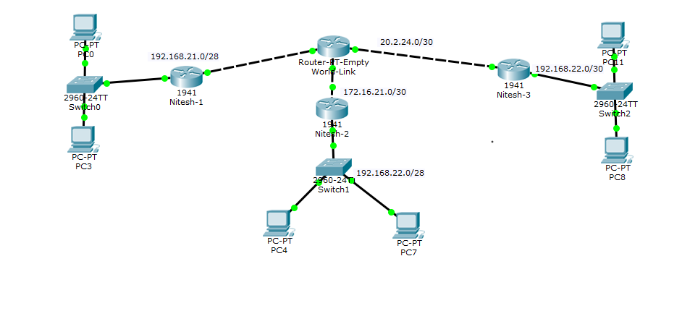F). Routing table is mostly used by routers to determine the path to the destination network. It is a set of rules which is used to determine where data packets are travelling over an Internet protocol IP network will be directed. A router uses its routing table to find the destination IP address and routes accordingly. For a packet to reach from its source to destination the address of the destination of both IP address and mac address should be know which is stored in the routing table of the device or the router.

routing done on cisco packet tracer .

# TASK 3

## Security

a).Here are list of seven measures that I have recommend which might keep the network secure.

1. Powerful antivirus is the first and the most important a company should a powerful anti-virus for the system a secure system means a secure network.
2. Use layered defense means implementing multiple approach to a security enforcement in different parts of a network which removes a single point of security failure.
3. Strong password policy means having a complex combination of alphanumeric and special characters which makes it difficult to break.
4. Securing the network using firewalls which can help you block unnecessary traffic
5. Tanning of employees. Having people who use the network understand and adhere to this security polices can help to control threats.
6. Data should have encryption once it is encrypted there will be a less chance of data theft.
7. Accounts for every user types should be created to organize the flow of data.

b.) The biggest threats to the system are viruses, Trojan and adware. Viruses and most common and the most dangerous one, Viruses are designed to spread from one computer to another. They are often disguised as email attachments or some downloaded file from the internet. They are known to corrupt and steal your data such as personal information and passwords. They are also known to disable your security features.

# TASK 4

# Diagram and explanation

Here I have drawn a network topology which includes network components like switch routers and pc.

A).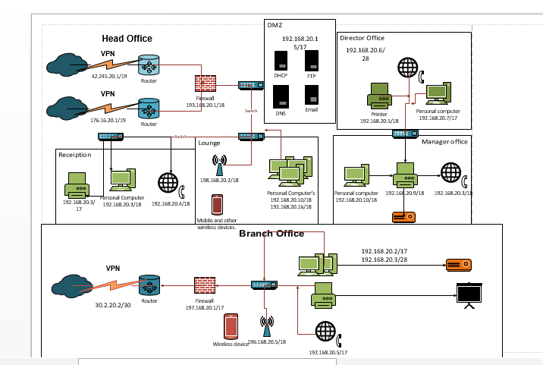

b. The diagram with IPV4 address assigned to them and the subnet mask some ISP that need

|  |  |  |  |
| --- | --- | --- | --- |
| IP Address | Subnet mask | Broadcast address | Used in |
| 43.245.20.1/19 | 255.255.224.0 | 43.245.31.255 | Vpn and router |
| 173.16.20.1/19 | 255.255.224.0 | 173.16.31.255 | Vpn and router |
| 193.168.20.1/18 | 255.255.192.0 | 192.168.63.255 | Firewall |
| 30.2.20.2/19 | 255.255.224.0 | 30.2.31.255 | Vpn and router |
| 192.168.20.15/17 | 255.255.128.0 | 192.168.127.255 | Server’s |
| 192.168.20.5/17 | 255.255.128.0 | 192.168.127.255 | Personal computers. |

c. Here are some particular hardware components and some reasons why I have connected them in a certain way. I have used Router which I have configured through firewall security. I have used switches to distrusted internet in different offices. The switches also help wireless access point to provide internet in the offices wirelessly. I have used Pc and printers to demonstrate workspace and given IP and accordingly. I have also used different servers like FTP to transfer files between office, DNS to automatically assign IP address, Email server which helps to Send and receive emails, DHCP server assigns’ new host.

d. Here are local prices and specification of suitable hardware/software you recommend.

|  |  |  |  |
| --- | --- | --- | --- |
| Device name | Model specification | Function | Price |
| Router | TP Link Archer C20 AC750 Wireless Dual Band | Routes packets to destination. | Rs.4, 500. |
| Desktops Computer | Dell OptiPlex 3060 | A basic working computer. | Rs.67,050 |
| Switch | TOTOLINK 8 Port Ethernet Switch | Receives and send | Rs.1,185 |
| Windows DHCP Server | 500 | Server that assigns IP address, default gateways and other network parameters. | Rs.41,775 |
| Printer | Canon Pixma G1010 | Prints Softcopies into hardcopies. | Rs.12,600 |

# Task 5

## Remote access

1. Secure remote access safeguards important data when the computer is accessed from computers outside the corporate network.  
   A VPN to the router/firewall/VPN server in the UK would be one appropriate solution.

Authentication - validates that the data was sent from the sender. Authentication can be set up both in system level and the network level.

Access Control - It is a security technique which regulates users and the use of resources in a computer environment, preventing unauthorized users from accessing the network.

Confidentiality – Is the state of keeping or being kept secret which helps in preventing the data from being read or copied as the data is being transported.

Data Integrity - Is the maintenance of and the assurance of the accuracy and consistency of data over its entire life-cycle ensuring that the data has not been altered.

1. When there is a mobile device accessing the system using remote access the ports have to be open in the system to allow the remote access to take place. Open ports are like open doors more doors are open the less secure the system becomes.
2. Benefits and security concern of installing Microsoft office 365 to centralize communication and software access are as follows.

|  |  |
| --- | --- |
| **Benefits** | **Security concern** |
| Work anywhereis the biggest advantages of office 365 as it enables to work from anywhere as long as you are connected to the internet. Due to it being cloud based the files can be accessed from any location or on any device. | Mobile device management is a security features which helps to manage office on employees phone to protect company information. If a phone containing company data is lost by an employee it remotely wiped out which protects the company data. |
| Collaborate easily as it helps everyone who needs to contribute to or edit a document (a spread sheet, or presentation) they can work on the same version rather than having multiple versions waiting to be combined | Data loss prevention is a set of o policies that check and prevents sensitive information like bank account number social security number from leaving your organization through email. |

d. VOIP is a telephone connection which sends information digitally using internet protocol rather than using analog telephone lines. Some benefits of using VOIP

Cost as it calls over internet can be cheaper and save a lot of money especially for any organization that need to handle lot of calls on a daily basis.

Multi functionality like call forwarding, call waiting, paging and many more which can deliver more enhance call processing which can bring higher possibilities.

# Conclusion

While handling the report I showed my knowledge of different accepts of computer networking like Network Infrastructure, Addressing, security, remote access and diagrams of logical network diagram. The report also completes the given requirement asked to fulfil by VansForHire.